UHF Smart Android RFID Handheld Reader
SBH-U25
SBH-U25 is a compact UHF RFID reader with a built-in antenna, operating in the 865–867 MHz range and supporting ISO 18000-6C and EPC Class 1 Gen 2 standards. It features Bluetooth connectivity for easy pairing with any Bluetooth-enabled device and includes a developer-friendly API, SDK, and an Android app with source code. Its portable design and quick integration make it ideal for mobile RFID applications.
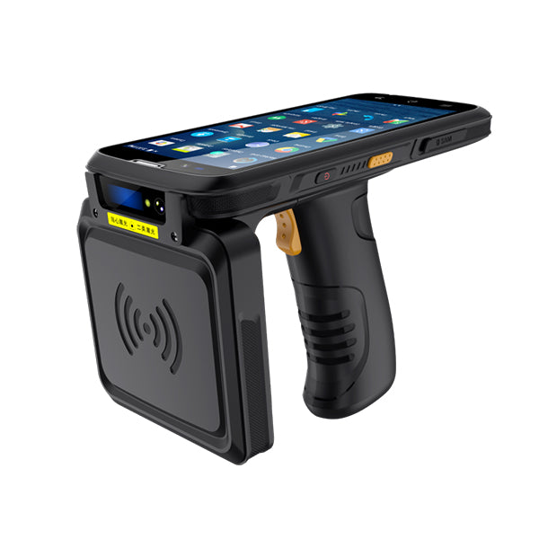
Features and Benefits:
- Ultra-Low Power Consumption with Smart Sleep Mode
- Fast Charging for Minimal Downtime
- Up to 6 Hours of Continuous Operation on a Single Charge
- Supports Desktop Reader Mode for Versatile Use
Applications:
- Inventory & Asset Management
- Logistics & Warehouse Operations
- Retail Stocktaking & Anti-Theft
- Field Service & Equipment Inspection
SPECIFICATIONS
Physical Parameters
Dimension | 69×117×25 mm
Weight | 150 gms approx.
Colour | Blue/Grey/Black
Technical Parameters
Operating Frequency | China (GB Standard):  - 920–925 MHz (Primary)  - 840–845 MHz (Optional)  Europe (ETSI Standard):  - 865–868 MHz (Optional)  India (TEC-Compliant Frequency Band):  - 865–867 MHz
Antenna | Inbuilt
Protocol | EPC Class 1 Gen2 (ISO 18000-6C)
Charging Time | 3 to 4 hours
Charging voltage | 5 VDC
Read Range | 300 to 500 mm
Interface | Bluetooth 4.0
Operating Temp | -10 to +50 C

Soochak Bharat, with its technical expertise in RFID technology, focuses on designing, developing, innovating, and deploying RFID hardware solutions.
*Read range is dependent on tag, antenna design and live location environmental factor. *Soochak Bharat reserves the right to make changes in the above specifications without notice.

